**TYPES OF PLANS AND GOALS**

**Why Plan?**

“Planning is about managing resources and priorities in an organized way,” Berry says. “Management is related to leadership, and it’s related to productivity.”

Plans commit individuals, departments, organizations, and the resources of each to specific actions for the future. Effectively designed organizational goals fit into a hierarchy so that the achievement of goals at low levels permits the attainment of high‐level goals. This process is called a **means‐ends chain** because low‐level goals lead to accomplishment of high‐level goals.

If companies improve how they plan, managing and leadership will also improve. The following steps can help businesses plan better.

* **Devise a Plan**: Write important details down and focus on strengths, what matters, what people are most important to you and what you can do for them. This will help you communicate your vision to your employees.
* **Define Success:** How do you see your business in several years? Define long-term goals and be specific. Establish milestones for certain goals and who will achieve the goals. Look at what drives your business; it may be presentations, conversions, page views or something else. Then establish a review schedule and re-examine your long-term goals as necessary.
* **Put It in Motion**: Track and analyze numbers to help you manage the work behind the numbers. You’ll be better able to make changes — or to develop new plans — that will help you manage better.

**The 4 Types of Plans**

Three major types of plans can help managers achieve their organization's goals: operational strategic and tactical. Operational plans lead to the achievement of tactical plans, which in turn lead to the attainment of strategic plans. In addition to these three types of plans, managers should also develop a contingency plan in case their original plans fail.

**1. Operational Planning**

“Operational plans are about how things need to happen,” motivational leadership speaker Mack Story said at LinkedIn. “Guidelines of how to accomplish the mission are set.”

This type of planning typically describes the day-to-day running of the company. **Operational plans** are often described as single use plans or ongoing plans. Single use plans are created for events and activities with a single occurrence (such as a single marketing campaign). Ongoing plans include policies for approaching problems, rules for specific regulations and procedures for a step-by-step process for accomplishing particular objectives.

The specific results expected from departments, work groups, and individuals are the operational goals. These goals are precise and measurable. “Process 150 sales applications each week” or “Publish 20 books this quarter” are examples of operational goals.

An operational plan is one that a manager uses to accomplish his or her job responsibilities. Supervisors, team leaders, and facilitators develop operational plans to support tactical plans (see the next section). Operational plans can be a **single use plan** or **an ongoing plan**.

* **Single use plans** apply to activities that do not recur or repeat. A onetime occurrence, such as a special sales program, is a single use plan because it deals with the who, what, where, how, and how much of an activity. A budget is also a single use plan because it predicts sources and amounts of income and how much they are used for a specific project.
* **Continuing or ongoing plans** are usually made once and retain their value over a period of years while undergoing periodic revisions and updates. The following are examples of ongoing plans:
* A **policy** provides a broad guideline for managers to follow when dealing with important areas of decision making. Policies are general statements that explain how a manager should attempt to handle routine management responsibilities. Typical human resources policies, for example, address such matters as employee hiring, terminations, performance appraisals, pay increases, and discipline.
* A **procedure** is a set of step-by-step directions that explains how activities or tasks are to be carried out. Most organizations have procedures for purchasing supplies and equipment, for example. This procedure usually begins with a supervisor completing a purchasing requisition. The requisition is then sent to the next level of management for approval. The approved requisition is forwarded to the purchasing department. Depending on the amount of the request, the purchasing department may place an order, or they may need to secure quotations and/or bids for several vendors before placing the order. By defining the steps to be taken and the order in which they are to be done, procedures provide a standardized way of responding to a repetitive problem.
* A **rule** is an explicit statement that tells an employee what he or she can and cannot do. Rules are “do” and “don't” statements put into place to promote the safety of employees and the uniform treatment and behavior of employees. For example, rules about tardiness and absenteeism permit supervisors to make discipline decisions rapidly and with a high degree of fairness.

**2. Strategic Planning**

“Strategic plans are all about why things need to happen,” Story said. “It’s big picture, long-term thinking. It starts at the highest level with defining a mission and casting a vision.”

**Strategic planning** includes a high-level overview of the entire business. It’s the foundational basis of the organization and will dictate long-term decisions. The scope of strategic planning can be anywhere from the next two years to the next 10 years. Important components of a strategic plan are vision, mission and values.

A **strategic plan** is an outline of steps designed with the goals of the entire organization as a whole in mind, rather than with the goals of specific divisions or departments. Strategic planning begins with an organization's mission.

**Strategic plans** look ahead over the next two, three, five, or even more years to move the organization from where it currently is to where it wants to be. Requiring multilevel involvement, these plans demand harmony among all levels of management within the organization. Top level management develops the directional objectives for the entire organization, while lower levels of management develop compatible objectives and plans to achieve them. Top management's strategic plan for the entire organization becomes the framework and sets dimensions for the lower level planning.

**3. Tactical Planning**

“Tactical plans are about what is going to happen,” Story said. “Basically at the tactical level, there are many focused, specific, and short-term plans, where the actual work is being done, that support the high-level strategic plans.”

A **tactical plan** is concerned with what the lower level units within each division must do, how they must do it, and who is in charge at each level. Tactics are the means needed to activate a strategy and make it work.

**Tactical plans** are concerned with shorter time frames and narrower scopes than are strategic plans. These plans usually span one year or less because they are considered short term goals. Long term goals, on the other hand, can take several years or more to accomplish. Normally, it is the middle manager's responsibility to take the broad strategic plan and identify specific tactical actions.

**Tactical planning** supports strategic planning. It includes tactics that the organization plans to use to achieve what’s outlined in the strategic plan. Often, the scope is less than one year and breaks down the strategic plan into actionable chunks. Tactical planning is different from operational planning in that tactical plans ask specific questions about what needs to happen to accomplish a strategic goal; operational plans ask how the organization will generally do something to accomplish the company’s mission.

**4. Contingency Planning**

Contingency plans are made when something unexpected happens or when something needs to be changed. Business experts sometimes refer to these plans as a special type of planning.

**Contingency planning** can be helpful in circumstances that call for a change. Although managers should anticipate changes when engaged in any of the primary types of planning, contingency planning is essential in moments when changes can’t be foreseen. As the business world becomes more complicated, contingency planning becomes more important to engage in and understand.

Intelligent and successful management depends upon a constant pursuit of adaptation, flexibility, and mastery of changing conditions. Strong management requires a “keeping all options open” approach at all times — that's where contingency planning comes in.

**Contingency planning** involves identifying alternative courses of action that can be implemented if and when the original plan proves inadequate because of changing circumstances.

Keep in mind that events beyond a manager's control may cause even the most carefully prepared alternative future scenarios to go awry. Unexpected problems and events frequently occur. When they do, managers may need to change their plans. Anticipating change during the planning process is best in case things don't go as expected. Management can then develop alternatives to the existing plan and ready them for use when and if circumstances make these alternatives appropriate.

**Overview of organizational structure and design departmentalization**

For Empire to be successful, the management structure requires simplicity and clarity.

**organizational structure**: It is how job tasks are formally divided, grouped, and coordinated within an organization. When managers develop or change the structure, they are engaged in organizational design, a process that involves decisions about six key elements: work specialization, departmentalization, chain of command, span of control, centralization and decentralization, and formalization.

**Organizing:** arranging and structuring work to accomplish an organization goals.

Purpose of organizing:

o Divides work to be done into specific jobs and departments,

o Assigns tasks and responsibilities associated with individual jobs,

o Coordinates diverse organizational tasks,

o Clusters job into units,

o Establishes relationships among individuals, groups and departments,

o Establishes formal lines of authority, o Allocates and deploys organizational resources.

**Work specialization:** dividing work activities into separate job tasks, also known as division of labor. This helps employees to be more efficient.

McDonald’s uses high work specialization to efficiently make and sell its products, and employees have precisely defined roles and standardized work processes. However, other organizations, such as Bolton, Ontario– based Husky Injection Molding Systems and Ford Australia, have successfully increased job breadth and reduced work specialization. Still, specialization has its place in some organizations. No hockey team has anyone play both goalie and centre positions. Rather, players tend to specialize in their positions.

**Departmentalization:** the basis which jobs are grouped together, such as

♣ Functional dept: groups according to function (engineering, accounting, manufacturing, hman resources, purchasing manager)

♣ Geographical dept: groups according to geographic region (western, southern, etc)

♣ Product dept: groups according to product line (mass transit, recreational, rail products sector, etc)

♣ Process dept: groups jobs on the basis of product of customer flow (sewing, planning, assembling, lacquering and sanding, etc)

♣ Customer dept: groups according to specific customers who have common needs (retail, wholesale, government accounts) Another popular model ◊Cross functional teams: work teams composed of individuals from various functional specialties and combined to make thing more efficient.

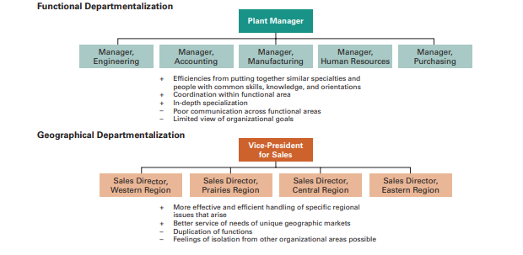

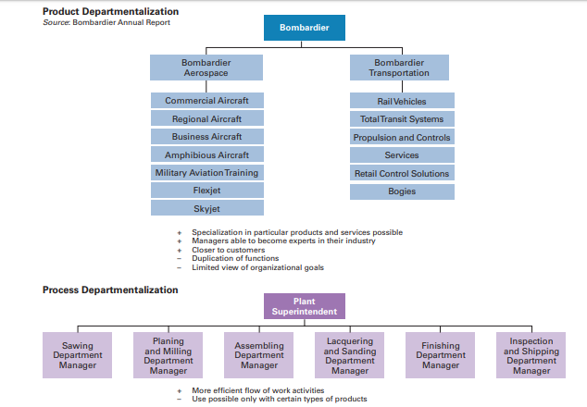

**Chain of command**

 It is defined as a continuous line of authority that extends from upper organizational levels to the lowest levels and clarifies who reports to whom. There are three important concepts attached to this theory:

* Authority: Refers to the rights inherent in a managerial position to tell people what to do and to expect them to do it.
* Responsibility: The obligation to perform any assigned duties.
* Unity of command: The management principle that each person should report to only one manager.

**Span of Control**

It is important to a large degree because it determines the number of levels and managers an organization has. Also, determines the number of employees a manager can efficiently and effectively manage.

**Today’s View**:The contemporary view of span of control recognizes that many factors influence the appropriate number of employees a manager can efficiently and effectively manage. These factors include the skills and abilities of the manager and the employees, and the characteristics of the work being done. **For example,** the more training and experience employees have, the less direct supervision they need. Therefore, managers with well-trained and experienced employees can function quite well with a wider span. Other contingency variables that determine the appropriate span include similarity of employee tasks, the complexity of those tasks, the physical proximity of subordinates, the degree to which standardized procedures are in place, the sophistication of the organization’s information system,the strength of the organization’s culture, and the preferred style of the manager.7 Wider spans of control are also possible due to technology—it is easier for managers and their subordinates to communicate with each other, and there is often more information readily available to help employees perform their jobs.

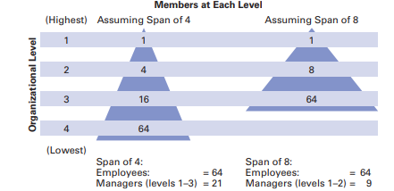

**Centralization and decentralization:**the degree to which decision making is concentrated at upper levels of the organization. The more that lower-level employees provide input or actually make decisions, the more decentralization there is.

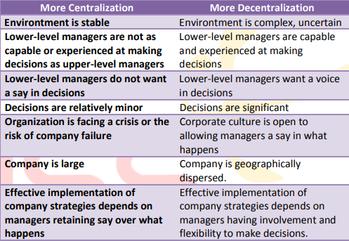

**Formalization Formalization:** refers to the degree to which jobs within the organization are standardized and the extent to which employee behaviour is guided by rules and procedures. If a job is highly formalized, the person doing that job has little freedom to choose what is to be done, when it is to be done, and how he or she does it. Employees can be expected to handle the same input in exactly the same way, resulting in consistent and uniform output. Organizations with high formalization have explicit job descriptions, numerous organizational rules, and clearly defined procedures covering work processes. On the other hand, where formalization is low, job behaviours are relatively unstructured, and employees have a great deal of freedom in how they do their work

# Goals are used to help a business grow and achieve its objectives. They can be used to foster teamwork and help the business describe what it wants to accomplish. Setting goals is an important part of any business plan.

# Six Types of Goal Setting

**Goal setting** is a management technique that involves developing an action plan with targets for a team or individual. It is considered both a tool of strategy implementation and performance management. As such, it is a critical management function that often follows a methodology, framework or standard across an organization.

**Setting goals** is the first step to getting what you want from your business. They give your work a sense of purpose and help you focus your limited time and energy on what’s important. Business goals also motivate and energize you to keep going when things get tough.

If you have the wrong business goals in place (or no goals at all), you won’t be clear on what you’re trying to achieve, and you’ll likely be half-hearted in your efforts. Even if you do reach those goals, the results won’t be as meaningful or feel as good as you might have hoped.

The following are a few common types of goal setting.

## 1. Mission Statements

A [short inspiring statement](https://simplicable.com/new/mission-statements) that captures your goals, principles and values.

## 2. Vision Statement

A vision statement paints a picture of your future. At the organizational level, it's an all encompassing goal for the future of the organization. As with mission statements, vision statements are usually short and catchy.

## 3. Big Hairy Audacious Goal

A Big Hairy Audacious Goal is an overly ambitious goal that you're not likely to achieve but represents a statement about your drive, determination and vision. They are commonly used to motivate employees and inspire customers.

## 4. SMART

SMART is the criteria that goals be specific, measurable, achievable, relevant and time-bound. It is commonly used in goal setting and project management. In many cases, the SMART criteria are used in conjunction with a goal setting methodology.

## 5. Management By Objectives

Management By Objectives is a management technique that implements strategies and manages performance with a process of participative goal setting.

## 6. Balanced Scorecard

A goal setting, strategy implementation and performance management methodology that sets measurable goals that map to strategy known as scorecards. Each scorecards includes data items in four areas: financial, customer, internal and learning.

Here are five things one need to consider for setting business goals

## 1. Professional vs. personal business goals

It’s easy to lose sight of your personal motivations as you bury yourself in work to try to grow the business.

When you consider possible business goals, your mind probably goes to getting more clients or earning more money. Those goals are important, but they are only part of the picture.

Think back to why you started freelancing or why you launched your business. You might have been motivated by more flexibility and time with your family. Maybe you wanted to be more creative or enjoy your work more. These are priorities that go beyond basic income and sales targets. Income makes all those other things possible, but money is rarely an end in itself.

When you’re setting goals, go beyond the obvious business-related areas. Consider things like:

* The maximum number of hours you want to work each week
* Specific days or time slots you want to have off
* Never missing your children’s sports days and performances
* Fitting in your yoga and meditation every day
* Gaining a specific qualification

Remember your most important priorities—and set business goals that reflect them.

## 2. Long-term vs. short-term business goals

Balancing a long-term vision with short-term goals will keep you inspired as well as focused on what you need to do to make that vision a reality.

As you define both your personal and professional goals, consider the timeframe for achieving them. You may have big dreams for the future, but with no impending deadline it’s easy to procrastinate. On the other hand, short-term goals can mean you miss out on the bigger picture by making incremental progress without having anything more substantial to aim for.

The best approach is to set both long-term and short-term business goals. First, create a big vision to inspire you and give you something meaningful to work towards. Next, break that down into specific goals with more urgent deadlines to focus your immediate efforts.

A big picture or lifetime vision might include:

* Reaching a specific income level
* Establishing a passive income stream
* Retiring early and traveling the world
* Re-locating to a new country
* Buying your dream house

Break this vision down into multiple long-term goals that you can achieve in 10 years, 5 years, 3 years and just one year.

For short-term goals, a three-month deadline is long enough for you to achieve big results, but short enough to maintain your focus. To make these goals even more achievable, break them down even further into monthly and weekly goals.

## 3. Outcome vs. process business goals

We should consider both the results that we’re aiming for (the outcome) and the actions we need to take to get there (the process).

Ultimately, business goals need to get you results. Your future outcome is what’s going to motivate you, and in a way, it doesn’t really matter how you get there!

Outcome goals are directly related to the results you’re aiming for, but you don’t always have complete control over whether or not you’ll get there. To make reaching that outcome more likely, you need to take specific actions. That’s where process goals come in.

Process goals are related to things you do have control over. For example:

* Sending a specific number proposals every week
* Following up with prospective clients every day
* Posting regularly on your social media channels
* Blocking your calendar to spend time with your family
* Signing up to an online course

Again, you’ll want a mix of both types of goals. Outcome goals usually correspond to that long-term vision that you’ve set, while process goals will be most useful for your short-term deadlines. For example, your one-year goal might be to increase your income by 50%, your three-month goal to get five new clients and your weekly goal to send at least five new proposals.

## 4. Quantitative vs. qualitative business goals

Numbers will help to make sure that the business is on track from a financial point of view but there will be other less tangible goals that you’ll want to set for yourself as well.

Business goals need to be specific enough so that you can track them and know when you’ve achieved them. “Growing the business” is far too vague, as is “getting more clients” or “spending more time with my children.”

Quantitative goals ensure that you have specific, measurable and achievable targets (this is where SMART comes in). Examples of quantitative goals are:

* Earn $10,000 in the next three months
* Get three new clients by the end of the month
* Work no more than 30 hours this week on the business

However, business goals that you can’t measure with numbers can be just as important. Qualitative goals might include:

* Feeling more confident
* Experiencing less stress
* Enjoying your work more
* Improving your writing or public speaking skills
* Finding a better balance between work and your personal life

Be as specific as you can by defining what “better” means or how much “more” you want of something. Using scales is also useful. Rate your confidence today (for example, 6 out of 10) and then set a goal for three months from now (8 out of 10). This will enable you to assess your progress on less tangible goals.

As always, make sure you have a balance between the two types of goals. Set quantitative goals to make sure that you’re on top of your financial targets, and set qualitative goals to capture the more nuanced aspects of what you’re trying to achieve with your business.

## 5. Ambitious vs. realistic business goals

Ambition is great but don’t let yourself get overwhelmed by the huge task that’s in front of you; break your big goal down into manageable chunks and milestones along the way.

Some finance coaches will tell you to define an income goal for the year—and then they’ll tell you to double it or even triple it. This kind of ambition can be inspiring and make you intensify your efforts. But it can also feel so daunting that you give up in the face of an impossible task.

A ‘dream’ goal or stretch goal can absolutely help motivate you to put that extra bit of effort in. And even if you don’t achieve it right away, you might get closer than you would have otherwise. However, stretch goals should be balanced with more realistic goals and milestones. You want to have little wins to celebrate along the way!

For example, you might have a stretch goal of creating a six-figure income alongside a more realistic goal of earning $10,000 more this year than last. Or you might dream of becoming a best-selling author, but your more realistic goal is to self-publish your first book this year.

Dream big, by all means. But set yourself those smaller goals to build your confidence and keep you going in the meantime.

Thus a goal is a result one is attempting to achieve. Management goals or objectives are a system of plans a company communicates to its employees to achieve. Management goal types are specific and clearly define objectives, measurable and have a system of regulating progress, are created to be achievable and have to be agreed upon. The goals set need to be realistic and have a deadline attached to them

**Strategic goals** are goals made to achieve and support the mission and vision of the company. Strategic goals effect and focus on an entire company and not just a department or work function within the company. Strategic goals include goals relating to innovation, market standing, productivity, efficiency in utilizing company resources in the form of workforce and finances, bottom line profit, management development and performance, employee conduct and morale and public and social responsibility. Strategic goals are set by organization leaders and apply to everyone within the organization to work on concurrently and will often benefit both the employee as well as the organization when goals are completed within the assigned time frame.

**Operational management goals** are goals set to impact the running of an organization, where management skills, technology and resources can be utilized in the most efficient ways possible. Operational goals are determined at the lower management level within an organization and are specific to certain employees or a department in the company versus the entire company. Operational goals focus on individual employee responsibilities and performance and the position's overall impact within the company.

**Tactical management goals** relate to the strategic goals set by the company. Tactical goals are broken into divisions or department levels and outline the steps necessary for each department within the organization to contribute to the larger strategic goals. Tactical goals are usually short term goals that contribute to the long-term company goal and can be analyzed and measured more easily.

**Super ordinate management goals** help to motivate individuals across different departments and are used to solve conflicts and establish relationships within the company. Superordinate goals allow employees and managers to work together at achieving strategic goals and recognize each person or department’s part in the overall objective. Value is added to the employee or department when the mutual benefits of each is recognized and praised and helps add a sense of individual accomplishment to working on the goal. Rewards are given out to employees for achieving goals and used as motivators.